**LIBRARY MANAGEMENT SYSTEM**



Session 2022-2026

**Submitted By:**

Mohsin Ali 2022-CS-193

**Supervised By:**

Prof. Dr. Awais Hassan

Department of Computer Science

**University of Engineering and Technology**

**Lahore Pakistan**

**Table of Contents**

**INTRODUCTION** 3

**USERS OF LIBRARY MANAGEMENT SYSTEM** 3

**OOP CONCEPTS** 3

**Association** 3

**Inheritance** 4

**Polymorphism** 4

**DESIGN PATTERN IMPLEMENTATION** 4

**CLASS DETAILS** 4

**VALIDATIONS** 5

**CRC DIAGRAM** 5

**WIREFRAMES** 6

**Fig. 1 : SignIn Page** 6

**Fig 1.5: Add Stock** 8

**Fig 1.6: Delete Stock** 8

**Fig 1.8: Offer Discount** 9

**Fig 1.9: Show Feedbacks** 10

**Fig 1.10: Customer Menu** 10

**Fig 1.11 : Check Bill** 11

**Fig 2.1 : Update Password** 11

**Fig 2.2 : Show Prices** 12

**Fig 2.3: Give Feedback** 12

**Fig 2.4: Show Bill** 13

**Class Details** 13

**BL CLASSES** 13

**USERBL** 13

**PHARMACYBL** 14

**MANAGERBL** 14

**CUSTOMERBL** 15

**FEEDBACKBL** 15

**DL CLASSES** 16

**USERDL** 16

**CUSTOMERDL** 17

**FEEDBACKDL** 17

**CONCLUSION** 18

# **VIDEO LINK:**

<https://youtu.be/M4f1uvxICPM>

<https://youtube.com/@MohsinAli-sq1mo>

# **INTRODUCTION**

The Pharmacy Management System is a comprehensive and user-friendly software solution that optimizes pharmacy operations for enhanced efficiency and customer satisfaction. With two primary user roles, the Admin and the Customer, the system offers a range of functionalities to meet their specific needs. The Admin has the authority to manage the pharmacy's inventory effectively by adding, deleting, and updating medicine stock. Additionally, they can monitor customer feedback to improve services and update their login credentials for heightened security. On the other hand, the Customer benefits from a seamless purchasing experience, where they can browse and buy medicines conveniently through the system. Moreover, customers can provide valuable feedback to help the pharmacy continually enhance its products and services. This robust Pharmacy Management System ensures smooth operations, fosters better customer relationships, and guarantees data protection for all users involved.

# **USERS OF LIBRARY MANAGEMENT SYSTEM**

o Customer

o Admin

# **OOP CONCEPTS**

The major concepts of OOP that have been used in this project include Association which further comprises of Aggregation and Composition. The other major concepts that have been used are Inheritance and Polymorphism.

## **Association**

**Aggregation** and **Composition** have been used many times. For example, pharmacy class from the BL folder has a relation of Compositon with pharmacyDL class. It is because without pharmacyDL class, no data will be store or load from file and then pharmacy class will be of no use because no data will be available. Similarly, the UserDL and the User class from BL are connected through composition. Same relation exists between Feedback class and feedbackDL.

## **Inheritance**

Inheritance is an important concept of OOP. It is used to reduce the duplication of data, by using inheritance, attributes can only be declared in a single parent class and then all of these can be used in child classes with the help of inheritance. This approach reduces the replication of data. The attributes in the parent class can be made either protected or private. For example, In this project User is the parent class and Sign In is the child class. The attributes of parent class can be accessed by child class. This is a conventional way of reducing replication and its very helpful in programming.

## **Polymorphism**

Polymorphism is an approach that helps us to describes situations in which something occurs in several different forms. Polymorphism is used when different functions are performing similar kind of tasks but there is a minor difference between them. For example, here we used it in customerDL class for getting the price of Medicine, while making it virtual and used the same function in the pharmacy class while overriding it. Polymorphism and Inheritance are linked with each other. There will be a Virtual function in parent class while child class will comprise of Override functions of the same name in other class.

# **DESIGN PATTERN IMPLEMENTATION**

Project comprises of three layers and whole project revolves around these three layers i.e. BL,DL and UI. The BL folder contain all the BL classes ,DL folder contain all the DL classes and UI folder contain all the UI classes All the attributes, constructors and logics are placed in the BL layers. The operations that are to be performed on the data are placed in the DL layers. The UI layers contains all those things that should be displayed on the screen. Moreover all the lists are placed in the respective DL layers. All these are connected with each other through different relations. The DL layers first get access to the BL layers to get the attributes. The UI layers need DL for performing different operations on data. In this way all layers are connected with each other in some way and in this this whole project works.

# **CLASS DETAILS**

The classes used in my project are listed below:

* customerBL
* feedbackBL
* managerBL
* pharmacyBL
* signInBL
* signUpBL
* userBL

The two main classes are userBL and pharmacyBL. They perform all the main functions of the system.

# **VALIDATIONS**

* While signing in, username and password should be greater than three letters.
* An admin or a user must sign up before signing in to the account.
* An admin or a user cannot sign up using the same username as the previous admin or user has entered, so the usernames must be unique.
* If the user or admin enters a number other than the choices given in the menu, they will have to enter the choice again.
* When selecting a medicine out of stock it gives error and customer has to select again.
* When medicine is purchased it is decreased from stock.
* In order to update password you have to remember old name and password.
* Cannot add new medicine with same name as existing one.

# **CRC DIAGRAM**

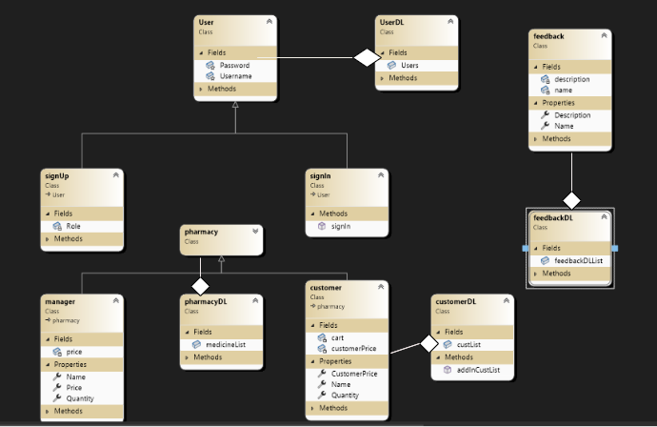

# **WIREFRAMES**

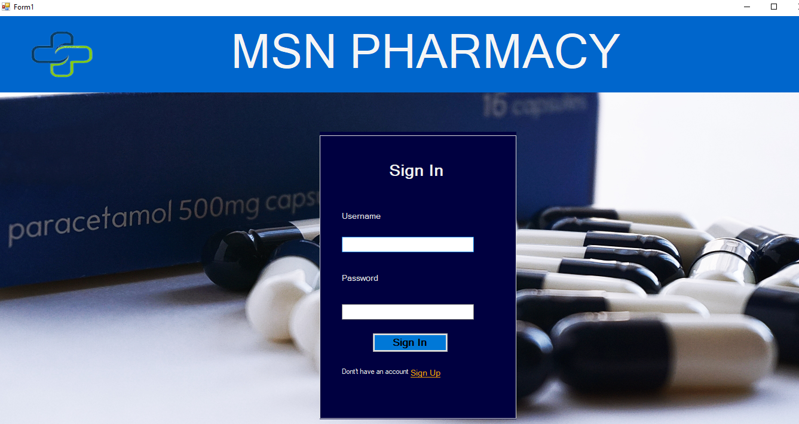

## **Fig. 1 : SignIn Page**

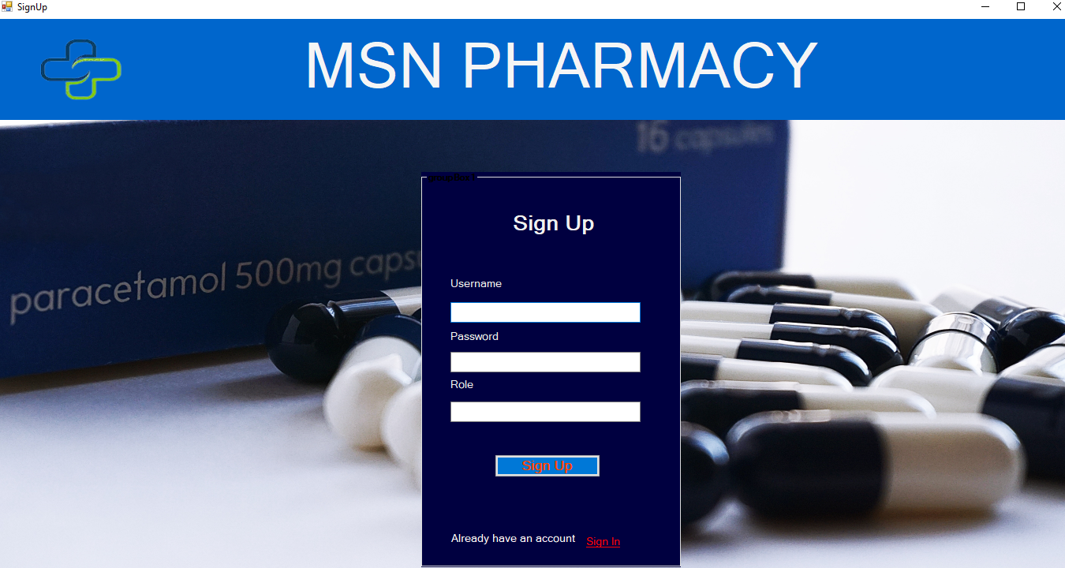

**Fig 1.1: SignUp page**

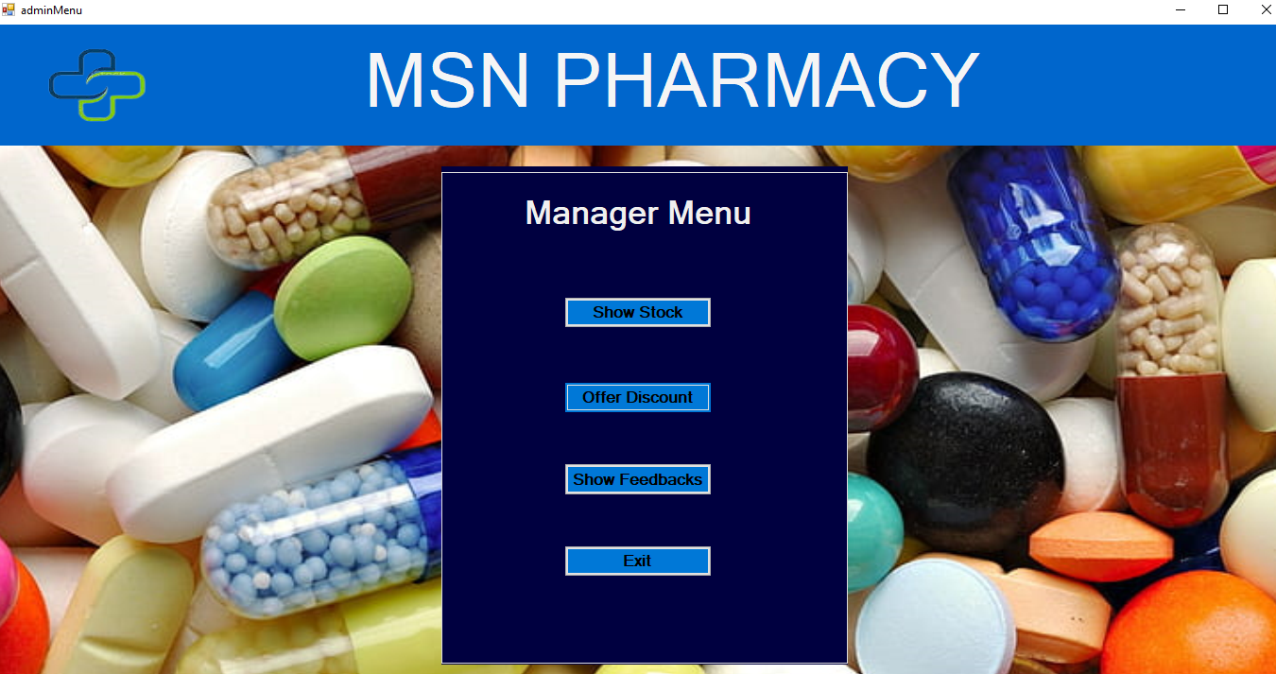

**Fig 1.3: Welcome Admin page**

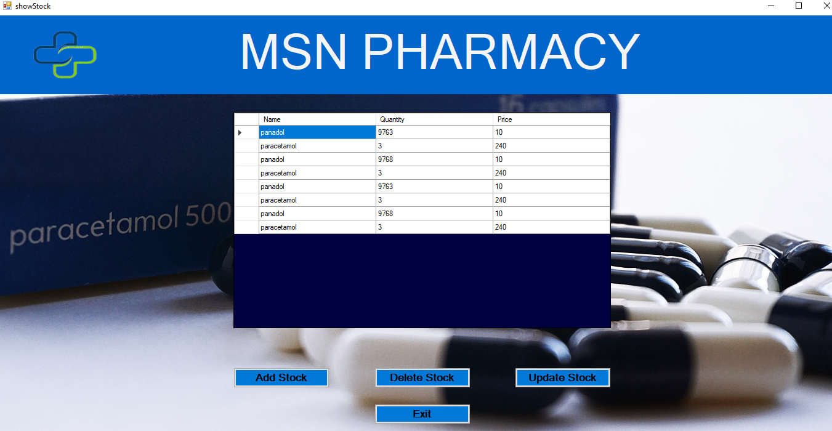

**Fig 1.4: Show Stock**

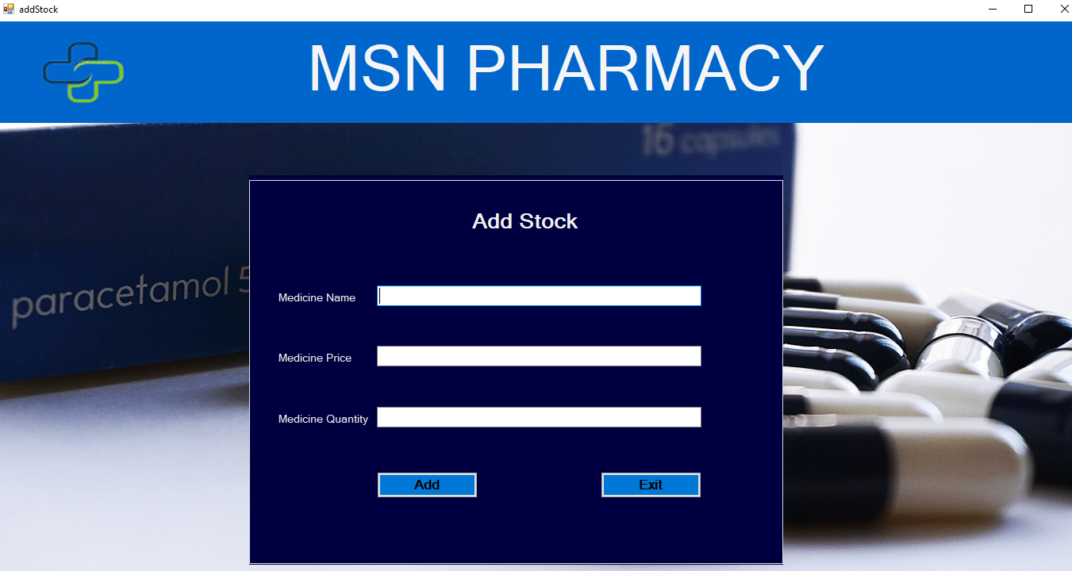

## **Fig 1.5: Add Stock**

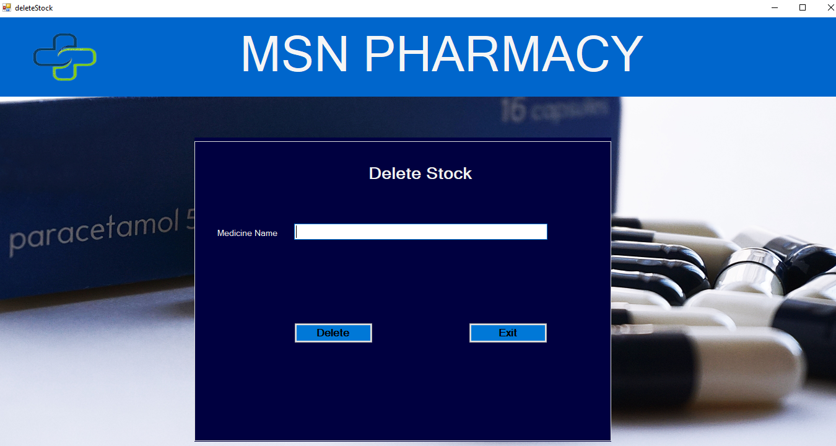

## **Fig 1.6: Delete Stock**

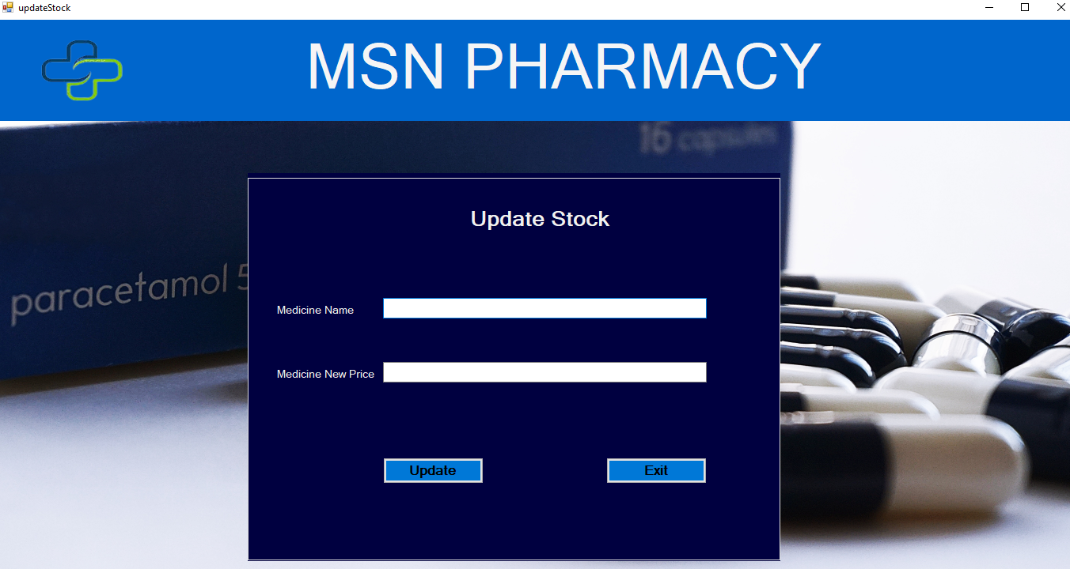

**Fig 1.7: Update Stock**

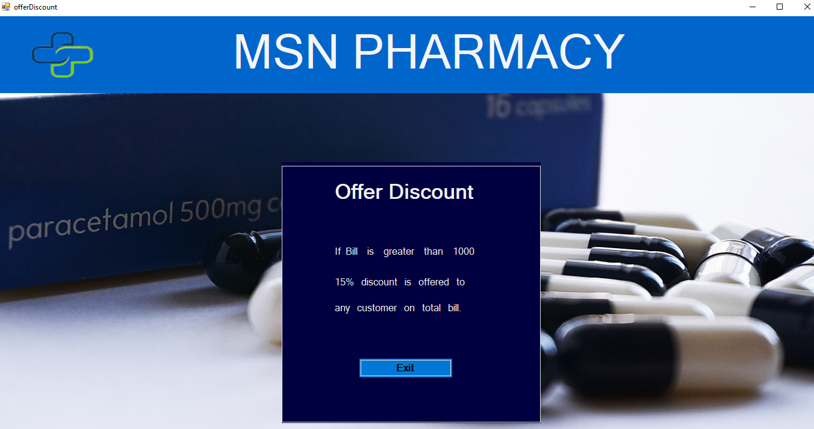

## **Fig 1.8: Offer Discount**

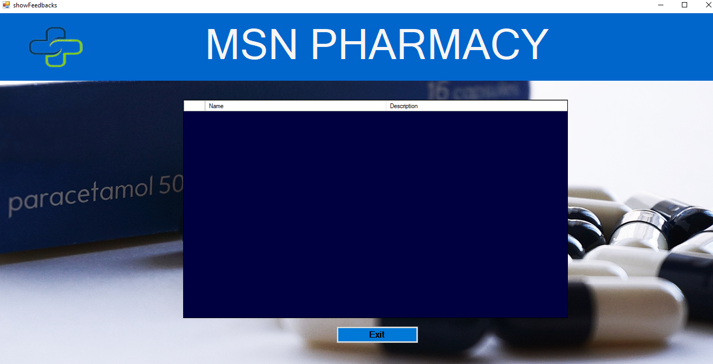

## **Fig 1.9: Show Feedbacks**

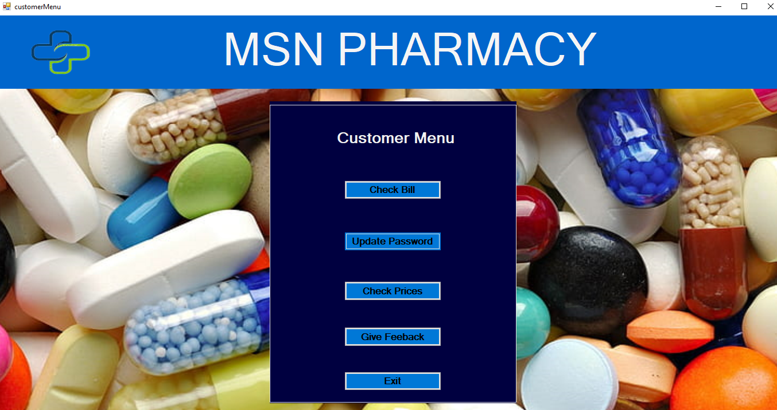

## **Fig 1.10: Customer Menu**

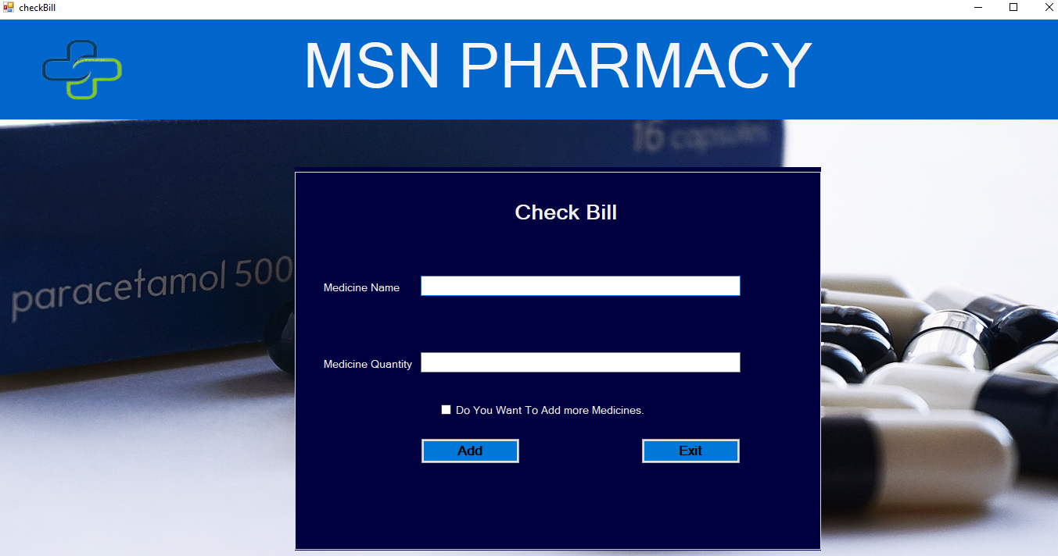

## **Fig 1.11 : Check Bill**

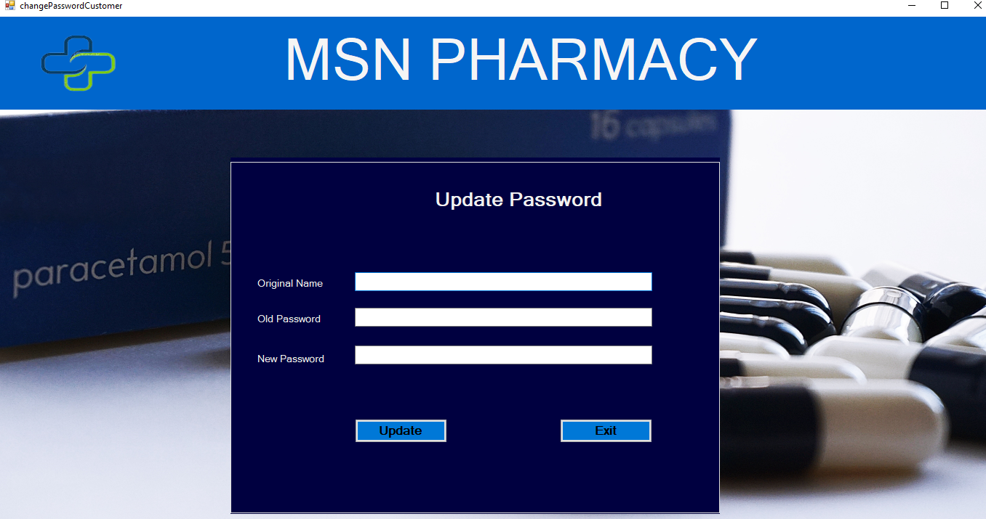

## **Fig 2.1 : Update Password**

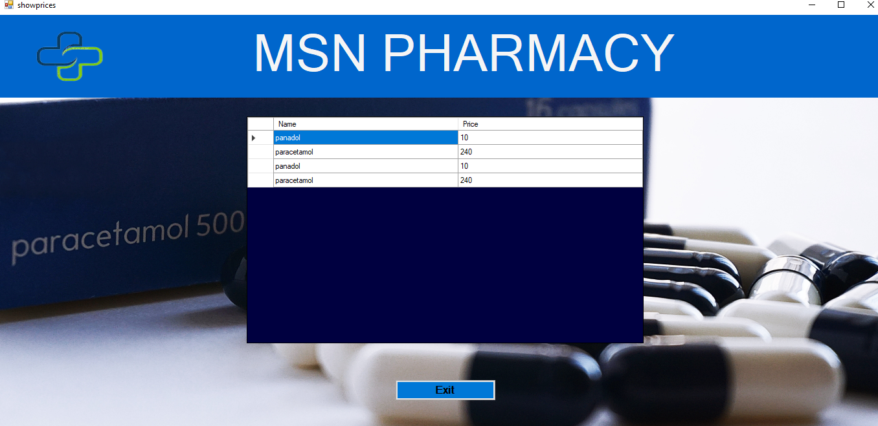

## **Fig 2.2 : Show Prices**

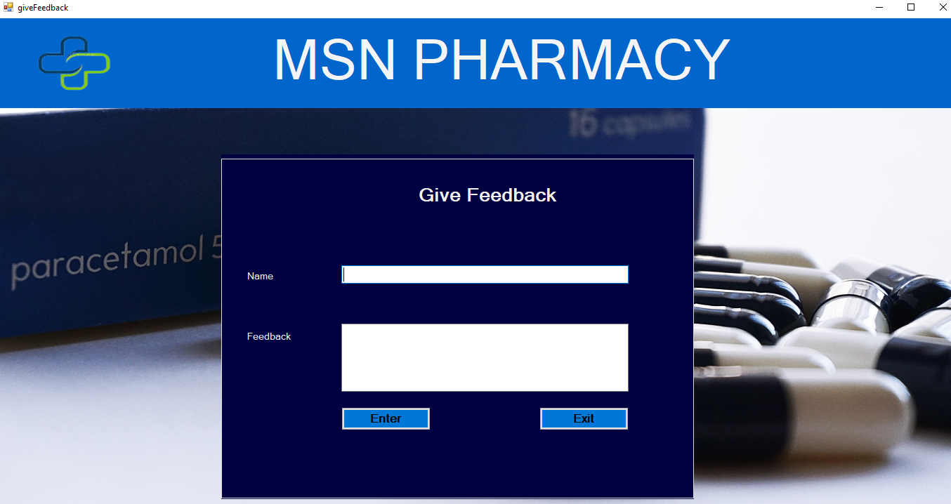

## **Fig 2.3: Give Feedback**

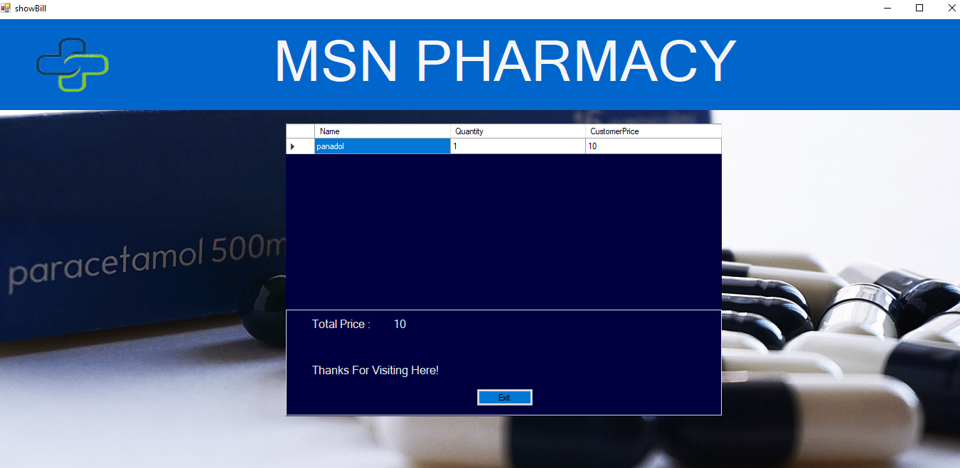

## **Fig 2.4: Show Bill**

# **Class Details**

Major classes in my project are BL and DL classes. All operations are performed in these classes so I’ll share code of these classes below:

## **BL CLASSES**

### **USERBL**

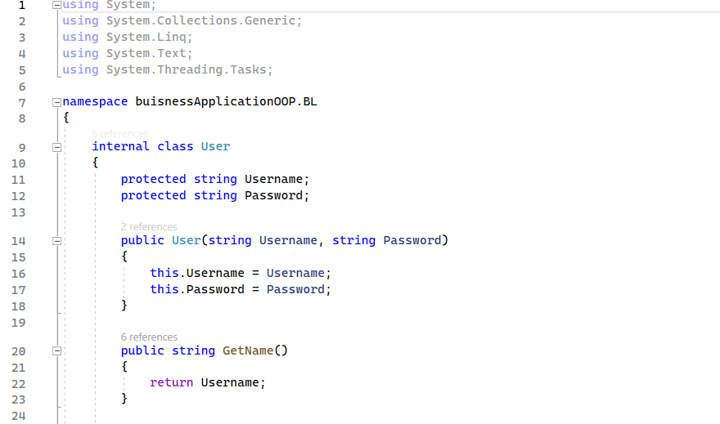

### **PHARMACYBL**

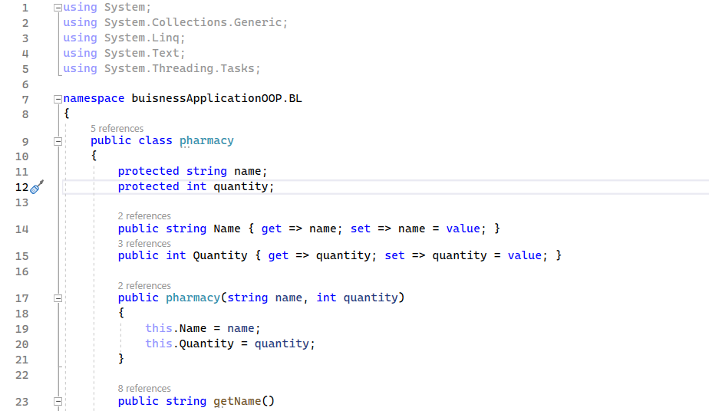

### **MANAGERBL**

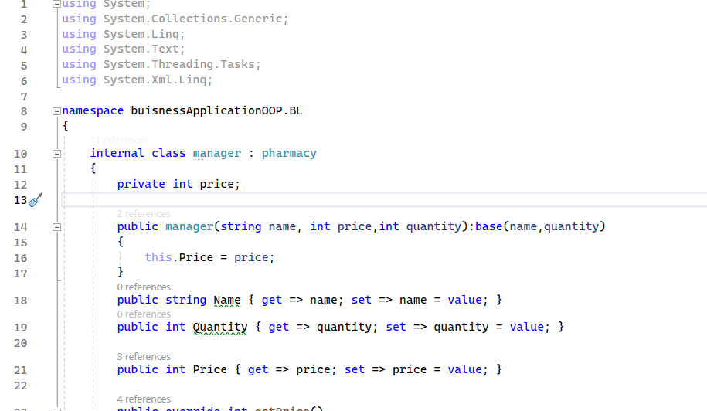

### **CUSTOMERBL**

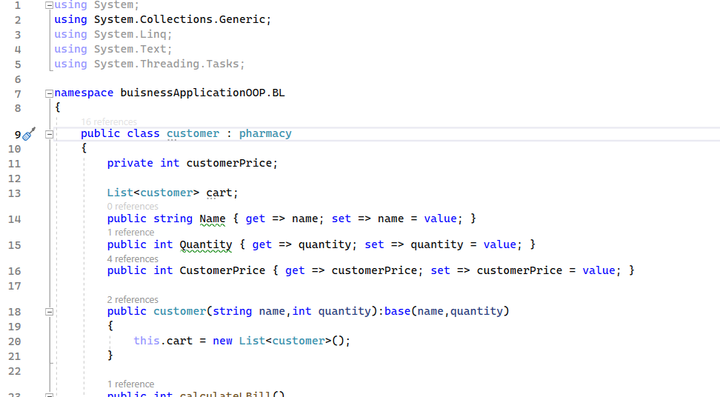

### **FEEDBACKBL**

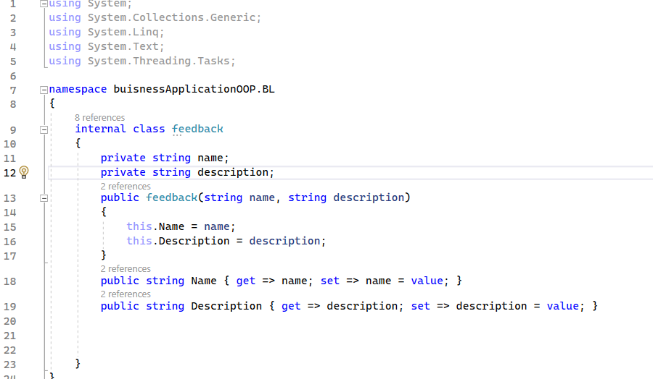

## **DL CLASSES**

### **USERDL**

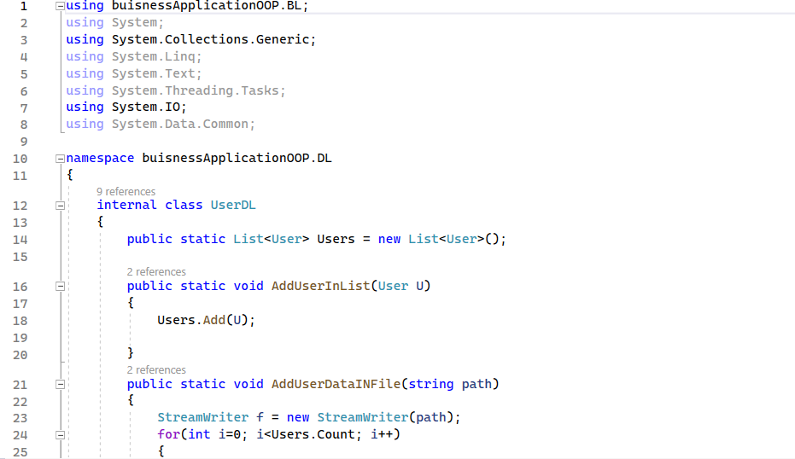

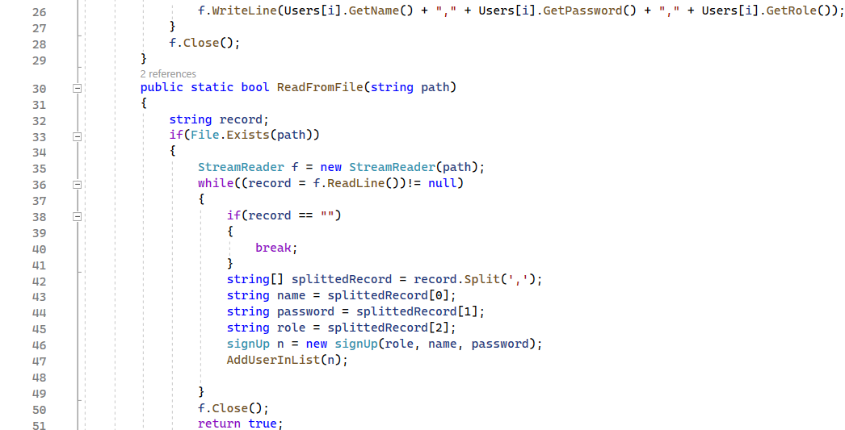

### **CUSTOMERDL**

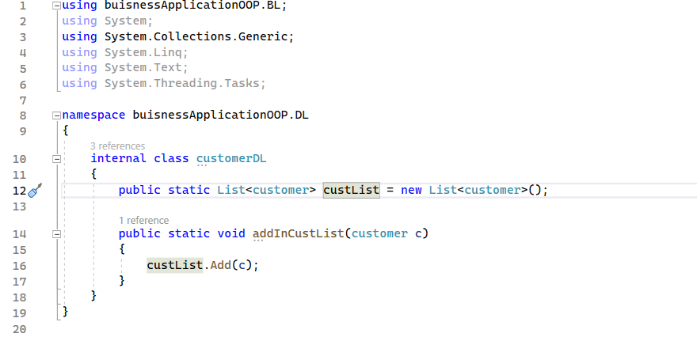

### **FEEDBACKDL**

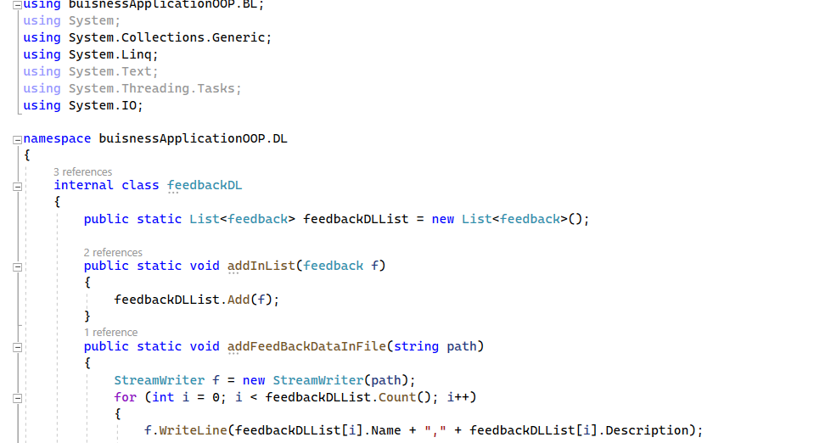

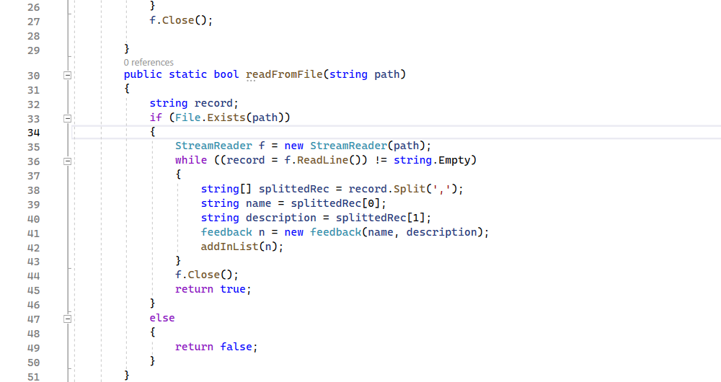

# **CONCLUSION**

This project has demonstrated its applicability across various pharmacy settings. Despite encountering several challenges, I adeptly navigated through them with the invaluable guidance and support of my teachers and teaching assistants. Among these obstacles, the notable complexity arose from integrating the concept of polymorphism into the project, given the absence of inherently similar functions. But at the end I resolve this issue too.

Throughout this enriching journey, I acquired invaluable insights, honing my proficiency in software development. Significantly, I gleaned essential lessons on data optimization, establishing data connections, and effectively implementing the principles of Object-Oriented Programming (OOP) within my project's architecture. Consequently, this undertaking exemplifies not only its versatility in pharmacies but also my prowess in tackling intricate challenges with resolute problem-solving abilities.